**Sevenmentor Pvt .Ltd**

**A**

**PROJECT REPORT**

**ON**

**Online FIR(First Information Report) System**

**IN PARTIAL FULFILLMENT OF THE DEGREE**

Java Full Stack

**Submitted By**

Mr. Mahamuni Tejas Rajkumar

**Under The Guidance**

**Of**

Mrs. Sarika Kore Mam

Year: 2023-2024

**ACKNOWLEDGEMENT**

We express our sincere thanks to Hon. Principle Dr. Mr. Rajmane of S.G.M. College, karad for providing us required university rule and regulation to complete this project work in time.

We are also thankful to Mr. Nalawade sir (HOD of C.S Department) and our guide Mrs .Pawar S.S. who encourage, advise and suggest us to successful complete our project. We are thankful to our librarian and there staff for providing us all library facilities time to time .We would like to thank to other teaching and nonteaching staff members of C. S. Department.

At last but not least, we are very much thankful to our parent and friends for co-operation to successfully complete this project in time.

Mr.Mahamuni Tejas Rajkumar

Place : Karad

Date :

**DECLARATION**

We hereby declare that, the industrial project entitled **“Online FIR(First Information Report) System”** has not formed earlier the basic for the award of degree of this or any other University or examination body.

Further we declared that we have not violated any of the provisions under copyright act.

Place: Karad

Date:

**INDEX**

|  |  |  |
| --- | --- | --- |
| **SR. NO.** | **NAME** | **PAGE NO.** |
| 1 | Introduction To Organization | 1-2 |
| 2 | Introduction To System And Project   * 1. About Project   2. Objective Of System   3. Scope Of System   4. User Requirement | 3-7 |
| 3 | Investigation Phase  3.1 Existing System  3.2 Proposed System | 8-10 |
| 4 | Requirement Analysis  4.1 Hardware And Software Requirement  4.2 Technology Used | 11-13 |
| 5 | System Analysis And Design  5.1 Feasibility Study  5.2 Data Flow Diagram  5.3 Entity Relationship diagram | 14-22 |
| 6 | User Interface Screens  6.1 Database Design  6.1 Form Design  6.2 Coding  6.3 Reports | 23-70 |
| 7 | Advantages and Limitations Of System | 71-72 |
| 8 | Conclusion | 73-74 |
| 9 | Future Enhancement | 75-76 |
| 10 | Bibliography | 77-78 |

**Chapter – 1**

**Introduction**

**To**

**Organization**

* **Introduction to Organization:**

**What is management:**

Management involves co-ordinating and overseeing the work activities of others so that their activities are completed efficiently and effectively.

A Online FIR(First Information Report) System is a software system designed to help Police Stations manage their resources and automate their day to day operations. It helps in managing Cognizable and Non Cognizable FIR’s and various administrative tasks.

The Online FIR System allows officers to catalog and classify cases, track FIR Progress and manage Suspect records. This system makes it easy for police to locate and check out cases, update cases . The system also helps police manage to generate reports.

**Chapter – 2**

**Introduction**

**To**

**System And Project**

* **Introduction To System And Project :**

**2.1 About project:**

The Online FIR (First Information Report) System is a web based project. This project is aimed to make transparency in Maharashtra Police Organization regarding to cases.

Talking about the features of the Online FIR system, it just contains the user section. The user (police) can add information of complaints in system, while the admin can manage the complaints of all users who have submitted the complaints.

Admin can verify and add users(new police stations) but also see the complaints that are saved by users in the database and admin can update the case details as per need.

It contains Information about acts that can easily use by users while typing or submitting new FIR. Therefore user is not required to keep track of all clauses or acts . User dose not need to recite of all acts while writing or submitting new FIR

Therefore, The design of this project is pretty simple so that the user won’t find any difficulties while working on it.

**2.2 Objective of the system:**

The main reason behind the development of the system is to overcome the problems and provide the good and quick service to user during system.

**The system consists many objectives as follows:**

1. To increase efficiency and make work effective.
2. This system also uses to current and quick working.
3. To reduce manpower and paperwork.
4. The objective of this system is to store large amount of data with less space and less time
5. To introduce drawbacks of manual system.
6. To provide good service and give desired and accurate result.
7. There is no loss of data.
8. Using computer software addition, modification, view is quickly possible.
9. It easier to the user to take look on any case in regarding police station

10)The system contains database where all the information will be stored Safely.

The main objective is to provide security, authority conclusion and further privacy and also is any unauthorized person cannot destroy or get information.

* 1. **Scope of system:**

**1) User facility :**

* Facility for search of Cases based on FIR ID, Complainant Name, Date of Case and Types Of Cases.
* Facility for search of FIR Progress based on Progress ID,FIR ID, Date of Case and Status of Case.
* Facility for search of Daily Diary based on Date.
* Facility for search of Suspect Details based on FIR ID ,Date when Suspect Found .
* Facility for Update Case Information ,FIR Progress, Suspect Details.

**2) Accuracy and efficiency:**

No wrong data is possible because of the validation checks by system.

**3) Early and correct decision making:**

Because of fast communication, report making procedure is simplified and fast.

**4) Advantages of computerization:**

To overcome limitation of existing system, computerization is correct choice of computer in any field and it reduce the time required to do a particular job.

**2.4 User requirement:**

* Although the system is a simple one, a user is able to understand simple computer processes is needed to run the system.
* The organizer will be the person who enter the data needed in to the system, thus an user needs also be efficient to utilize easy manual work that can be provided by this software.
* The system also needs MySQL Server for the organizations database management system.
* Different information is entered into the database such as information about the cases.
* Correct information is to be entered in to the system to prevent mismanaged conflicts to occur. This view makes the information provided by the system to reliable and useful.
* The target users of the system are deemed to understand basic computer processes so use of this system will be easy for them.

**Chapter – 3**

**Investigation Phase**

* **Investigation Phase**

**3.1 Existing system:**

* In existing system there are lots of paper work and manual processing.
* Records very carefully as the entire data is written in those book
* Everything is paper based hence it is very time consuming more than person can’t access the data at same time
* All works were done by user and hence the correctness is very low.
* The manually system work very difficult and very complex for manages Cases.

**Need for new system:**

* Keep proper records of Cases.
* It also maintains correct and quick processing to get some printed output or records. Fir’s , Suspect Details, FIR Progress etc.
* The main objective of this system to store large amount of data within less time
* The most important objective is to provide the security. Authority security and further privacy and also provide management of information very quickly.
* To overcome some problem that comes during existing system.
* Now the day, everyone lives with very fast life; no one can wait a time consuming so new system do the necessary and speedy job daily easily and quickly.

**3.2 Proposed System:**

Computer is manmade machine. It takes some data as input process as per instruction and give result very quickly and accurately. System is an orderly grouping interdependent component linked together to according to plan to achieve specific objective.

There are many drawbacks in manual system. To overcome these all drawbacks there is need of computerization there are many chances of mistakes.. It is easy to generate output which can received quickly therefore it save the time and energy so fact is reduce man power automatically.

It proposed system when we enter information for new entries, details of event on computer then within fraction of time output will generate. As well as we see total information of particular Police Station and the information about particular field is updated automatically you can create pdf receipt on these proposed system. We can see Outputs at any time on system.

**Chapter – 4**

**Requirement Analysis**

* **Requirement Analysis**

**4.1 Hardware and software requirement:**

System specification divided into two categories. You must have certain software and hardware installed on your computer. The minimum system specifications include.

* **HARDWARE SPECIFICATION**

1)OPERATING SYSTEM: WINDOWS 11

2)RAM: 8GB

3)PROCESSOR: INTEL CORE i5 11TH GEN

4)SOLID STATE DRIVE: 1 HDD

* **SOFTWARE SPECIFICATION**

1. ECLIPSE IDE FOR ENTERPRIZE JAVA AND WEB DEVELOPERS
2. APACHE TOMCAT 9.0 SERVER
3. MYSQL 8.0.31 SERVER

**4.2 Technology Used:**

Java is general-purpose computer-programming language that is concurrent, class-based, object-oriented, and specifically designed to have as few implementation dependencies as possible. It is intended to let application developers “write once, run anywhere“(WORA), meaning that compiled Java code can run on all platforms that support Java without the need for recompilation. Java applications are typically compiled to byte code that can run on any Java virtual machine (JVM) regardless of computer architecture. As of 2016, Java is one of the most use, particularly for client-server web applications, with a reported 9 million developers. Java was originally developed by **James Gosling** at **“Sun Microsystems”**(which has since been acquired by Oracle Corporation) and released in 1995 as a core component of Sun Microsystems' Java platform. The language derives much of its syntax from C and C++, but it has fewer low-level facilities than either of them.

There were five primary goals in the creation of the Java language:-

1. It must be "simple, object-oriented, and familiar".

2. It must be "robust and secure".

3. It must be "architecture-neutral and portable".

4. It must execute with "high performance".

5. It must be "interpreted, threaded, and dynamic".

**Chapter – 5**

**System Analysis**

**And**

**Design**

* **System Analysis And Design**

**5.1 Feasibility Study:**

The main objective of feasibility study is to test the technical, social and economic of developing a system. This is done by investigation the existing system in the area under investigation and generation idea about the new system. Prior to the system developed a thorough study of the system is carried out involves…….

* Identification of user requirement.
* Identification how different tasks are carried out.
* Identification whether proposed system can meet the user requirement.
* Providing technical, economical, operational feasibility of the proposed system.

The details of the feasibility study are given below:-

**TECHNICAL FEASIBILITY :-**

* The system is developed by using Eclipse IDE which has already installed on the computer system. The machine configuration also supports the system.
* The system being user friendly, data entre & reports generation is made easy. o Easy retrieval and access of data is provided.

**OPERATIONAL FEASIBILITY** :-

* Cost of implementation of the system as well as the installation that to consider in the operational feasibility. After implementation of the system there is need to arrange training program for users of the system.
* Expenditure for this system is also a part of this of his study.

**ECONOMIC FEASIBILITY** :-

Economical feasibility is basically a cost benefit analysis. The cost concerned is….

* The cost for system development.
* The cost of hardware, software for the system is presented economical.
* The benefit can be seen in form cost cutting due to fast working.
* The user training is also included in cost of making the software, so it is beneficial deal

**5.5.1 Zero Level DFD**

0-Level DFD

User

Online FIR System

Report

Admin

Register New Police Station (User)

FIR Progress

Register New FIR

Suspect Details

Police Diary

0.0

**5.5.2 First Level DFD**

1-Level DFD

Request for login

Response

1.0

5.0

4.0

3.0

2.0

Response

Request for login

User

Admin

View FIR Progress

View Daily Diary

View Suspect details

View FIR Info

Add/Update Progress Details

Add/Update Daily Updates

Add/Update Suspect Details

Register/Update New FIR

**5.4 ER Diagram**

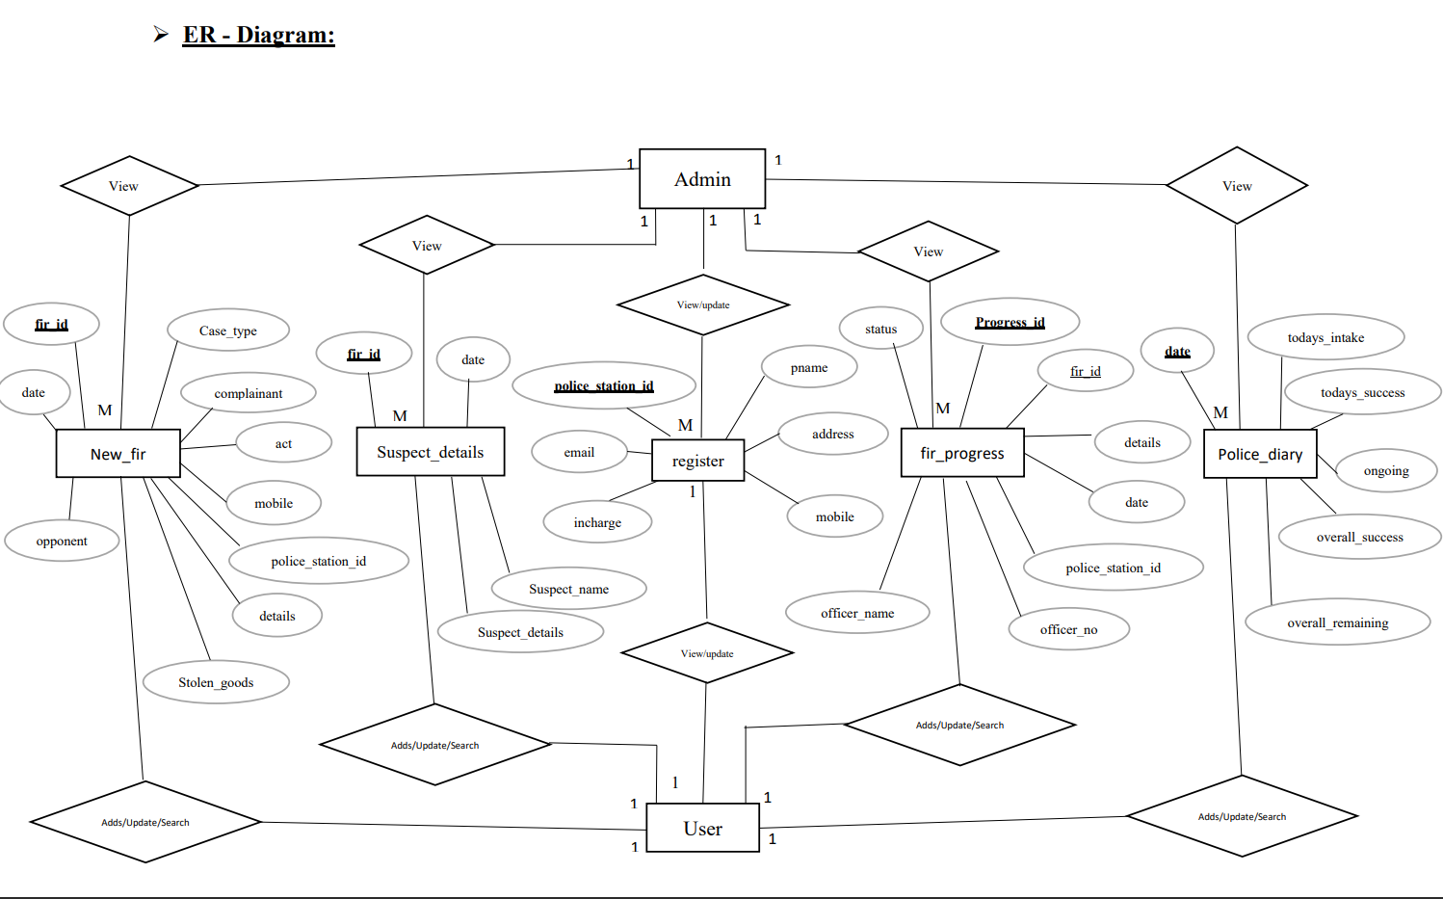

**Chapter – 6**

**User Interface Screens**

**6.1 Database Design**

1. **Register Table :**

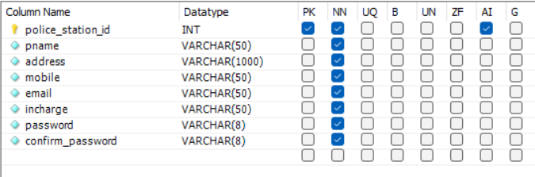

**2.New FIR Table :**

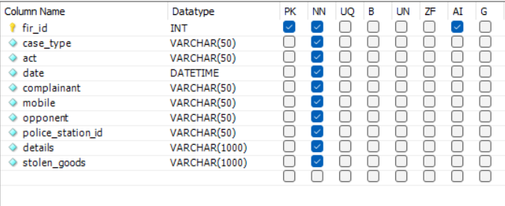

**3. Suspect Details Table :**

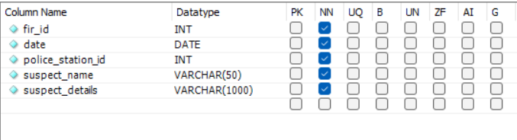

**4.Fir Progress Table :**

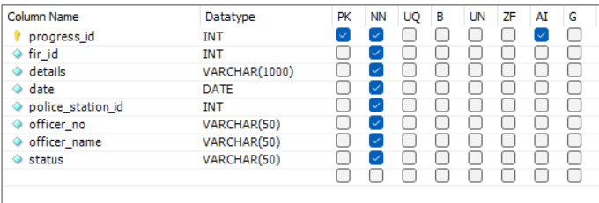

**5.Police Diary Table :**

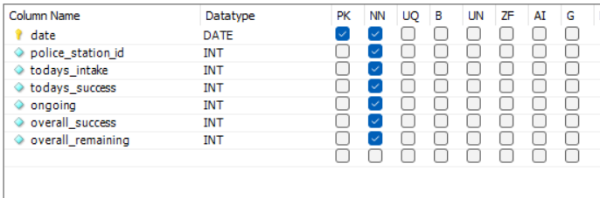

**6.2 Form Design**

1. **Home Page**

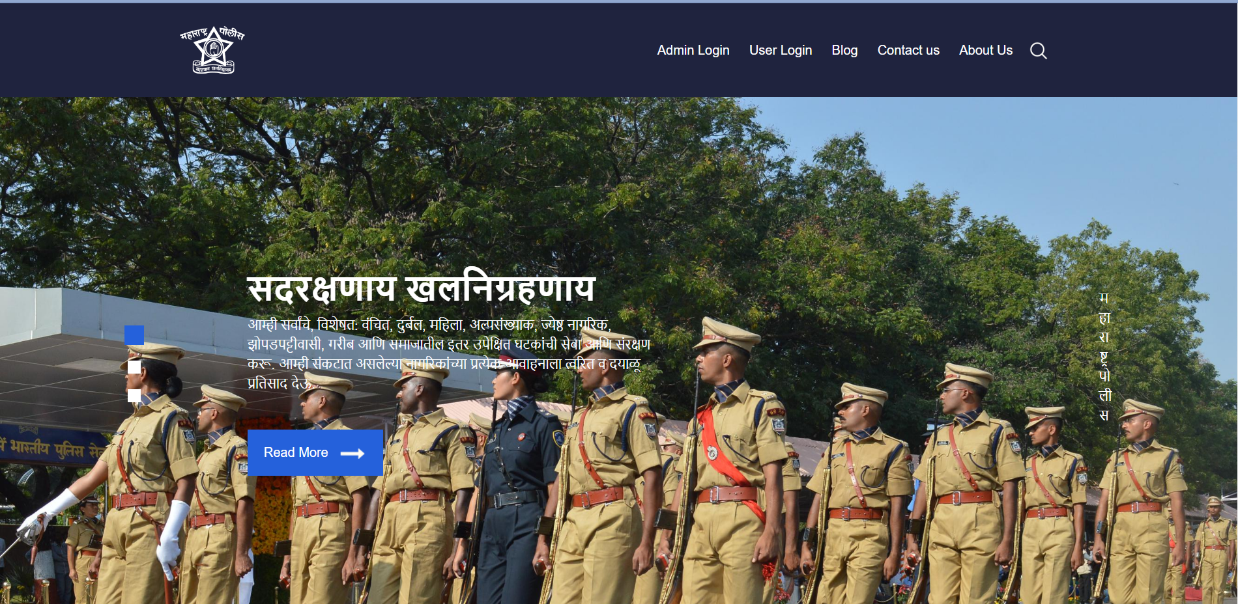

1. **Admin Login**

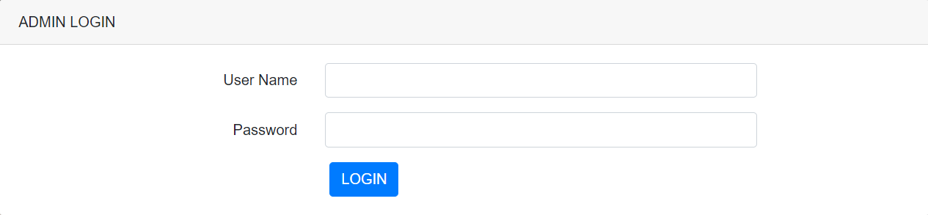

1. **Admin Home**

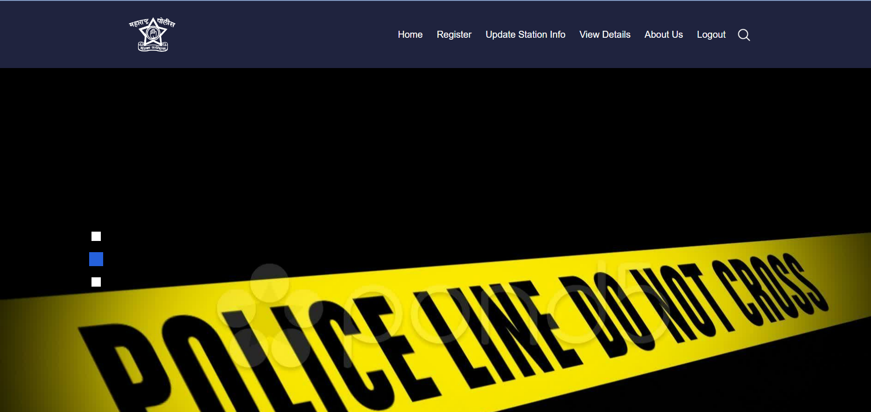

1. **Register**

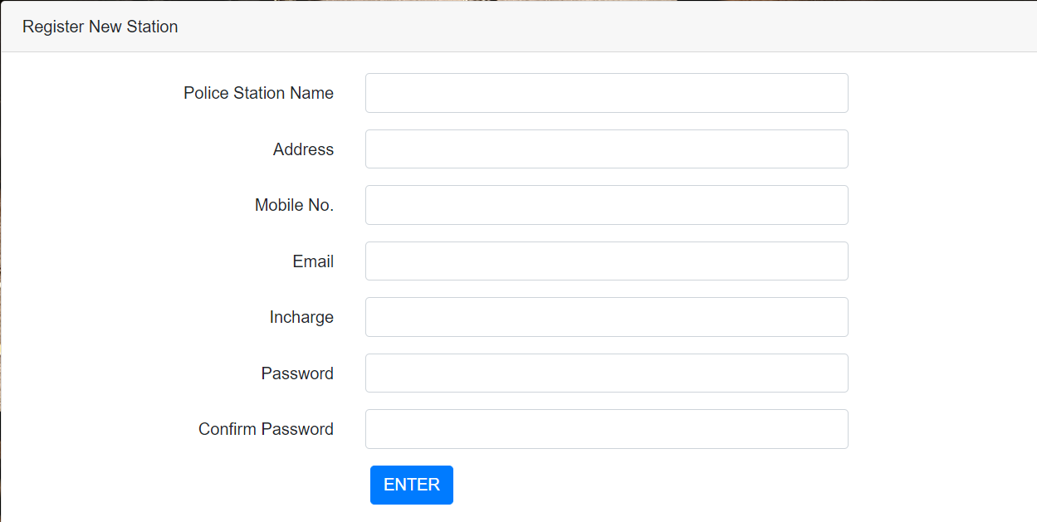

1. **User Login**

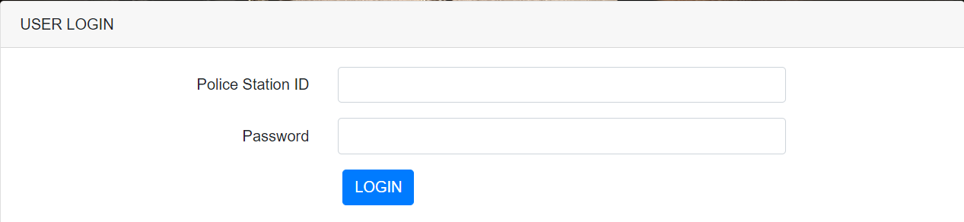

1. **User Home**

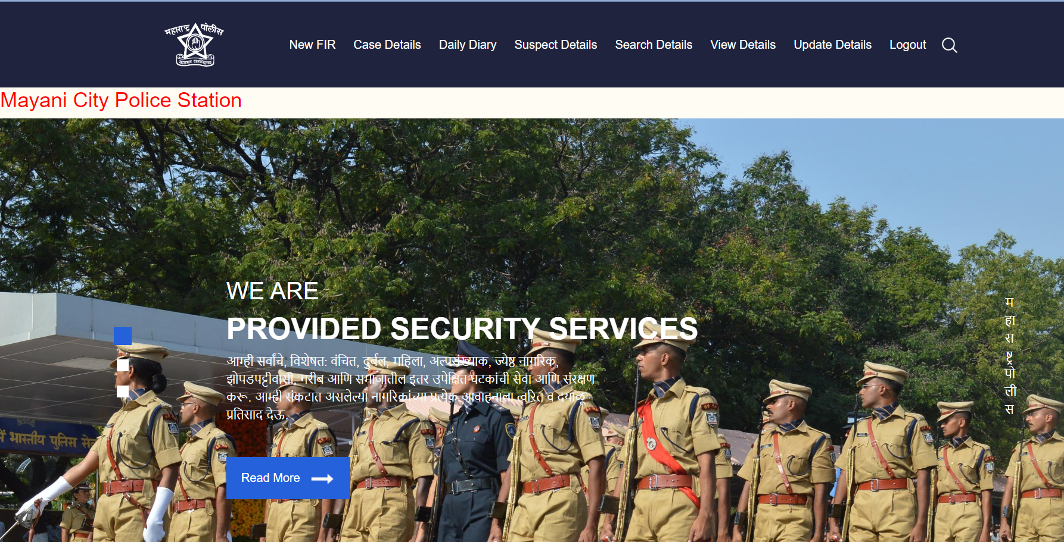

1. **Cognizable FIR**

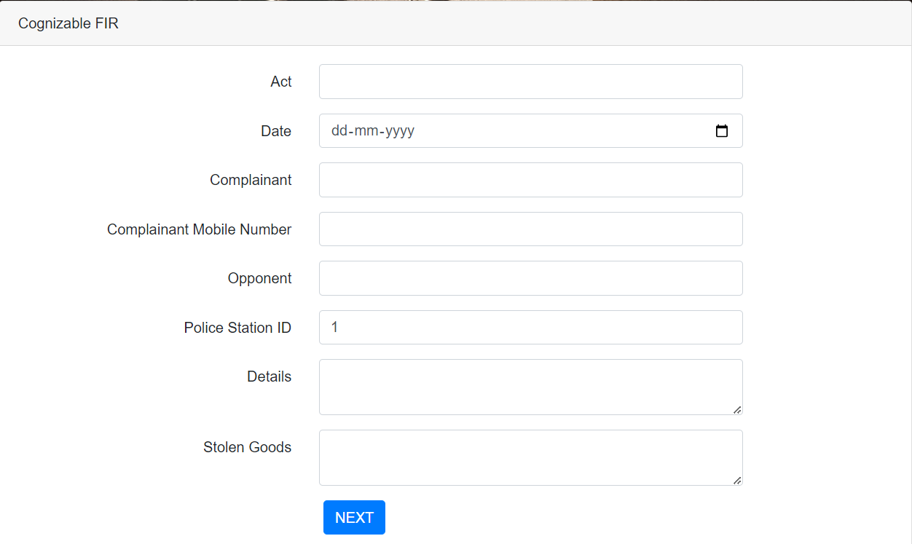

1. **Non Coginzable FIR**

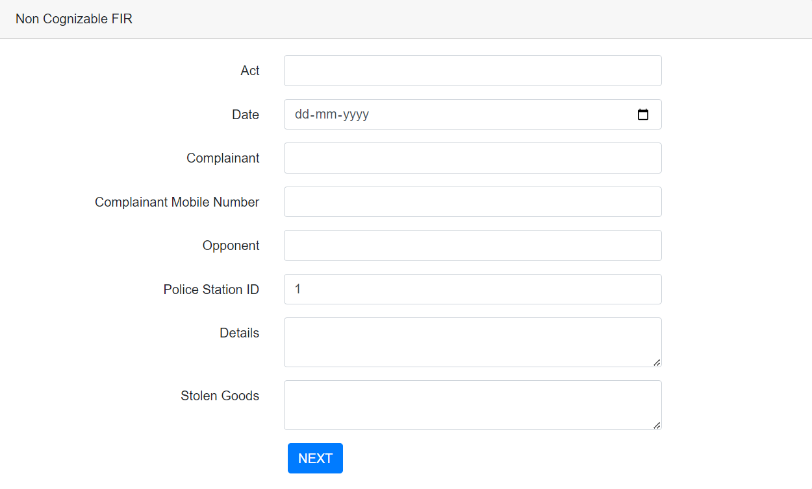

1. **Case Details/FIR Progress**

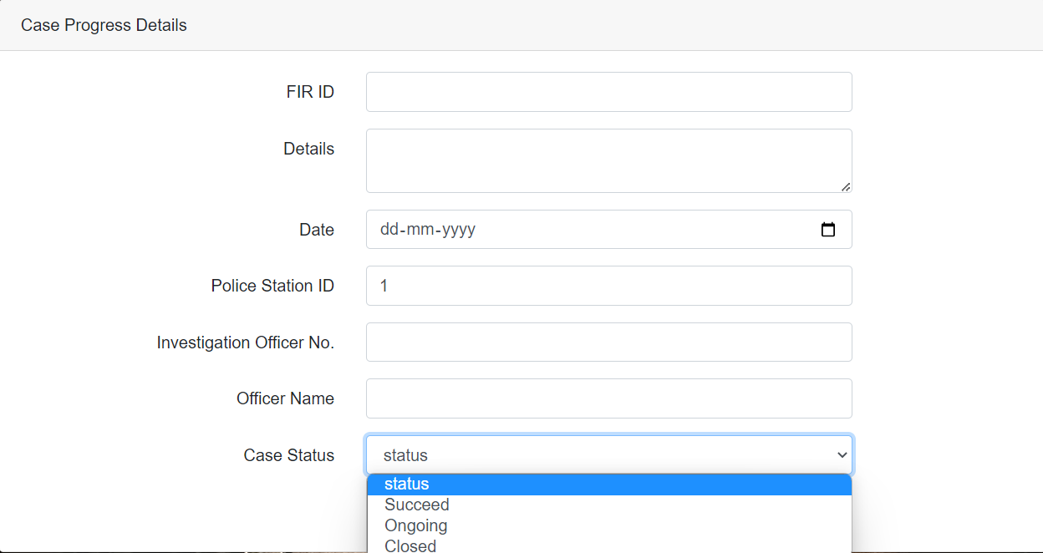

1. **Daily Diary**

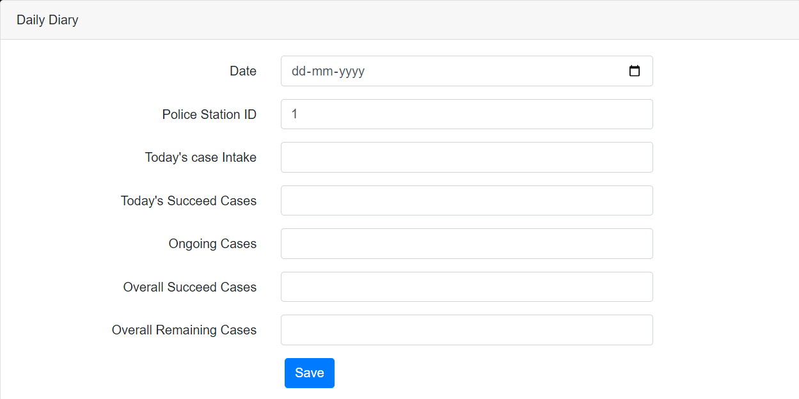

1. **Suspect Details**

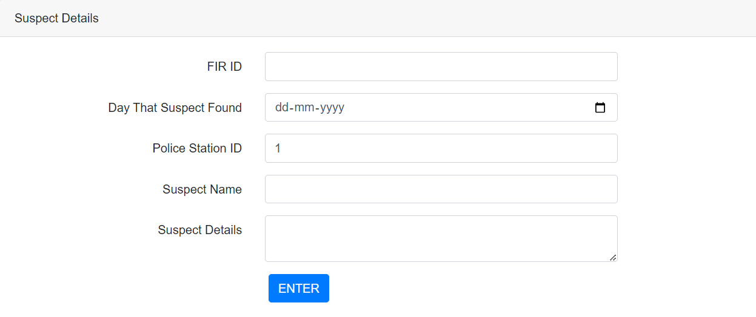

1. **Search FIR**

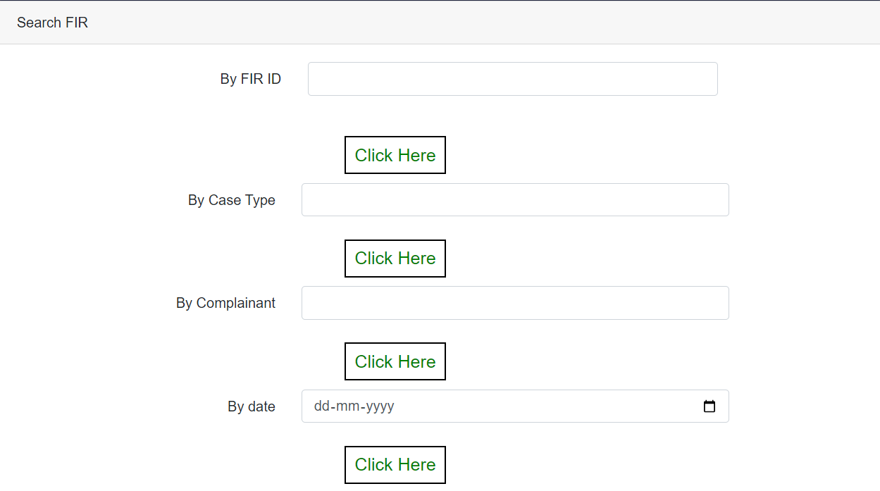

1. **Search FIR Progress**

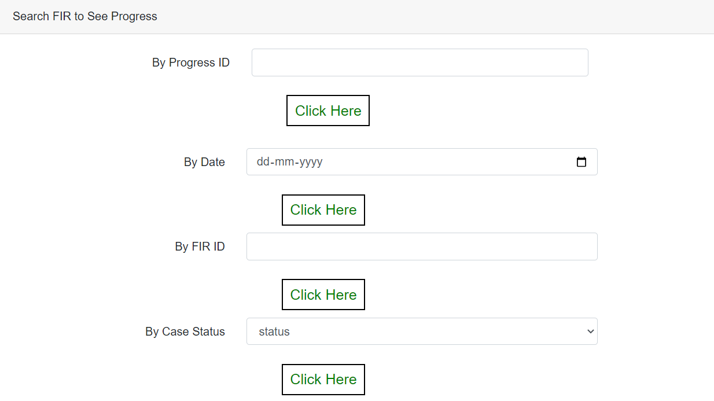

1. **Search Daily Diary**

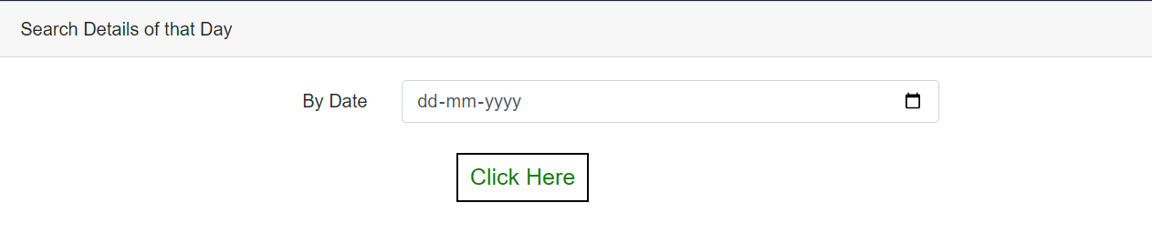

1. **Search Suspect Details**

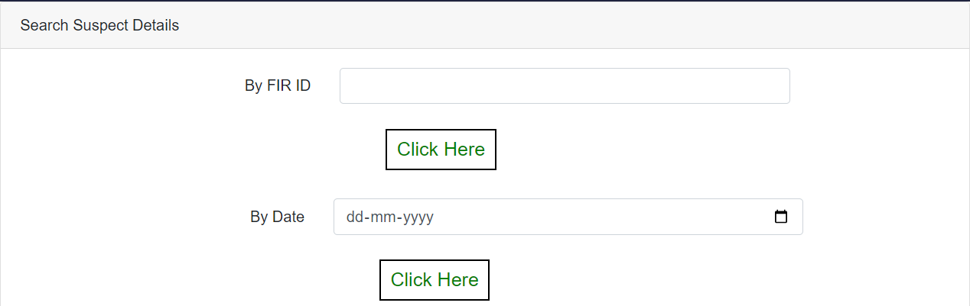

**6.2 Coding**

**1)DConnection Code:**

<%@page import=*"java.sql.*"* %>

<%!

**public** **class** DConnection {

Connection con;

ResultSet rs=**null**;

Statement st;

**public** **int** setData(String str){

**int** i=0;

**try**{

Class.forName("com.mysql.jdbc.Driver");

System.out.println("------driver loaded------------------");

//con = java.sql.DriverManager.getConnection("jdbc:mysql://localhost:3306/performancedb", "root", "root");

con = DriverManager.getConnection("jdbc:mysql://localhost:3306/fir","root","12345");

//con = DriverManager.getConnection("jdbc:mysql://localhost:3306/lms","root", "root");

st=con.createStatement();

st.execute(str);

i = st.getUpdateCount();

}**catch**(Exception e){ }

**return** i; }

**public** ResultSet getData(String str) {

**try**{

Class.forName ("com.mysql.jdbc.Driver");

con = DriverManager.getConnection("jdbc:mysql://localhost:3306/fir","root","12345");

st=con.createStatement();

rs = st.executeQuery(str); }

**catch** (Exception e){ }

**return** rs;

} } %>

**2)Home Page Code**

<%@ page language=*"java"* contentType=*"text/html; charset=UTF-8"*

pageEncoding=*"UTF-8"*%>

<html>

<head>

<meta charset=*"utf-8"* />

<meta http-equiv=*"X-UA-Compatible"* content=*"IE=edge"* />

<meta name=*"viewport"* content=*"width=device-width, initial-scale=1, shrink-to-fit=no"* />

<meta name=*"keywords"* content=*""* />

<meta name=*"description"* content=*""* />

<meta name=*"author"* content=*""* />

<title>Maharashtra Police</title>

<link rel=*"stylesheet"* type=*"text/css"*

href=*"https://cdnjs.cloudflare.com/ajax/libs/OwlCarousel2/2.1.3/assets/owl.carousel.min.css"* />

<link rel=*"stylesheet"* type=*"text/css"* href=*"css/bootstrap.css"* />

<link href=*"https://fonts.googleapis.com/css?family=Open+Sans:300,400,600,700|Roboto:400,500&display=swap"*

rel=*"stylesheet"* />

<link href=*"css/style.css"* rel=*"stylesheet"* />

<link href=*"css/responsive.css"* rel=*"stylesheet"* />

</head>

<body>

<!-- header section strats -->

<header class=*"header_section"*>

<div class=*"container"*>

<nav class=*"navbar navbar-expand-lg custom_nav-container "*>

<a class=*"navbar-brand"* href=*"#"*>

<div class=*"logo_box"*>

<img src=*"images/logo1.png"* alt=*""* />

</div></a>

<button class=*"navbar-toggler"* type=*"button"* data-toggle=*"collapse"* data-target=*"#navbarSupportedContent"*

aria-controls=*"navbarSupportedContent"* aria-expanded=*"false"* aria-label=*"Toggle navigation"*>

<span class=*"navbar-toggler-icon"*></span>

</button>

<div class=*"collapse navbar-collapse"* id=*"navbarSupportedContent"*>

<ul class=*"navbar-nav ml-auto mr-2"*>

<li class=*"nav-item"*><a class=*"nav-link"* href=*"Adminlogin.jsp"*>Admin Login</a></li>

<li class=*"nav-item"*><a class=*"nav-link"* href=*"Userlogin.jsp"*>User Login</a></li>

<li class=*"nav-item"*><a class=*"nav-link"* href=*"blog.html"*>Blog</a></li>

<li class=*"nav-item"*><a class=*"nav-link"* href=*"contact.html"*>Contact us</a></li>

<li class=*"nav-item"*><a class=*"nav-link"* href=*"about.html"*>About Us </a></li>

</ul>

<form class=*"form-inline my-2 my-lg-0"*>

<input class=*"form-control nav_search-input mr-sm-2 d-none"* type=*"search"* placeholder=*"Search"*

aria-label=*"Search"* value=*""* />

<button class=*"btn my-2 my-sm-0 nav_search-btn"* type=*"submit"*></button>

</form></div></nav></div>

</header>

<!-- end header section -->

<!-- slider section -->

<section class=*" slider_section"*>

<div id=*"carouselExampleIndicators"* class=*"carousel slide vert"* data-ride=*"carousel"*>

<ol class=*"carousel-indicators"*>

<li data-target=*"#carouselExampleIndicators"* data-slide-to=*"0"* class=*"active"*></li>

<li data-target=*"#carouselExampleIndicators"* data-slide-to=*"1"*></li>

<li data-target=*"#carouselExampleIndicators"* data-slide-to=*"2"*></li>

</ol>

<div class=*"carousel-inner"*>

<div class=*"carousel-item active"*>

<div class=*"slider_box"*>

<div class=*"fixed_company-detail"*>

<p>महाराष्ट्र पोलीस</p></div>

<div class=*"slider-detail"*>

<div class=*"slider_detail-heading"*>

<h1>सदरक्षणाय खलनिग्रहणाय</h1></div>

<div class=*"slider_detail-text"*><p>

आम्ही सर्वांचे, विशेषत: वंचित, दुर्बल, महिला, अल्पसंख्याक, ज्येष्ठ नागरिक, झोपडपट्टीवासी, गरीब आणि समाजातील इतर उपेक्षित घटकांची सेवा आणि संरक्षण करू. आम्ही संकटात असलेल्या नागरिकांच्या प्रत्येक आवाहनाला त्वरित व दयाळू प्रतिसाद देऊ.

</p></div>

<div class=*"slider_detail-btn"*>

<a href=*"homeblog.jsp"*><span>Read More</span><img src=*"images/arrow.png"* alt=*""* class=*"ml-2"* />

</a></div></div></div></div>

<div class=*"carousel-item"*>

<div class=*"slider_box1"*>

<div class=*"fixed_company-detail"*></div>

<div class=*"slider-detail"*>

<div class=*"slider_detail-heading"*></div>

<div class=*"slider_detail-text"*></div>

<div class=*"slider_detail-btn"*></div></div></div></div>

<div class=*"carousel-item"*>

<div class=*"slider_box2"*>

<div class=*"fixed_company-detail"*></div>

<div class=*"slider-detail"*>

<div class=*"slider_detail-heading"*></div>

<div class=*"slider_detail-text"*></div>

<div class=*"slider_detail-btn"*></div></div></div></div></div>

<a class=*"carousel-control-prev"* href=*"#carouselExampleIndicators"* role=*"button"* data-slide=*"prev"*>

<span class=*"carousel-control-prev-icon"* aria-hidden=*"true"*></span>

<span class=*"sr-only"*>Previous</span></a>

<a class=*"carousel-control-next"* href=*"#carouselExampleIndicators"* role=*"button"* data-slide=*"next"*>

<span class=*"carousel-control-next-icon"* aria-hidden=*"true"*></span>

<span class=*"sr-only"*>Next</span></a></div></section>

<!-- footer section -->

<section class=*"container-fluid footer_section"*>

<p>Copyright &copy; 2023 All Rights Reserved By Maharashtra Police </p>

</section>

<!-- footer section -->

<script type=*"text/javascript"* src=*"js/jquery-3.4.1.min.js"*></script>

<script type=*"text/javascript"* src=*"js/bootstrap.js"*></script>

<script type=*"text/javascript"* src=*"https://cdnjs.cloudflare.com/ajax/libs/OwlCarousel2/2.2.1/owl.carousel.min.js"*>

</script>

<script type=*"text/javascript"*>

$(".owl-carousel").owlCarousel({

loop: **true**,

margin: 20,

nav: **true**,

navText: [],

autoplay: **true**,

autoplayHoverPause: **true**,

responsive: {

0: {

items: 1

},

600: {

items: 2

},

1000: {

items: 3

}

}

});

</script>

<script>

$(".nav_search-btn").click(**function** () {

**if** ($(".nav_search-input").hasClass("d-none")) {

event.preventDefault();

$(".nav_search-input")

.animate({

left: "-1000px"

},

"1000000"

)

.removeClass("d-none");

} **else** {

$(".nav_search-input")

.animate({

left: "0px"

},

"1000000"

)

.addClass("d-none");

}

});

</script>

<script>

// This example adds a marker to indicate the position of Bondi Beach in Sydney,

// Australia.

**function** initMap() {

**var** map = **new** google.maps.Map(document.getElementById('map'), {

zoom: 11,

center: {

lat: 40.645037,

lng: -73.880224

},

});

**var** image = 'images/maps-and-flags.png';

**var** beachMarker = **new** google.maps.Marker({

position: {

lat: 40.645037,

lng: -73.880224

},

map: map,

icon: image

});

}

</script></script>

</body>

</html>

**3)Admin Login Form**

<div class=*"card"*>

<div class=*"card-header"*>ADMIN LOGIN</div>

<div class=*"card-body"*>

<form name=*"my-form"* onsubmit="return validform()" action=*"Adminlogin1.jsp"* method=*"POST"*>

<div class=*"form-group row"*>

<label for=*"username"* class=*"col-md-4 col-form-label text-md-right"*>User Name</label>

<div class=*"col-md-6"*>

<input required type=*"text"* id=*"username"* class=*"form-control"* name=*"username"*></div></div>

<div class=*"form-group row"*>

<label for=*"pass"* class=*"col-md-4 col-form-label text-md-right"*>Password</label>

<div class=*"col-md-6"*>

<input required type=*"password"* pattern=*"(?=.*\d)(?=.*[a-z])(?=.*[A-Z]).{8,}"* id=*"pass"* class=*"form-control"* name=*"pass"*></div></div>

<div class=*"col-md-6 offset-md-4"*>

<button type=*"submit"* class=*"btn btn-primary"*>LOGIN</button></div>

</form></div></div>

**4)Admin Login Connection Code**

<%@page import=*"java.sql.*"* %>

<%@ page import=*"java.sql.*"* %>

<%@page import=*"java.io.*"* %>

<%@page import=*"java.net.*"* %>

<%

String user = request.getParameter("username");

String pwd = request.getParameter("pass");

String u="";

String p="";

u=user;

p=pwd;

**if** (user.equals("Admin") && pwd.equals("Tejas@1604"))

{

response.sendRedirect("adminhome.jsp");

}

**else**

{

response.sendRedirect("Adminlogin.jsp");

}

%>

**5)User Login Form**

<div class=*"card"*>

<div class=*"card-header"*>USER LOGIN</div>

<div class=*"card-body"*>

<form name=*"my-form"* action=*"Userlogin1.jsp"* method=*"post"*>

<div class=*"form-group row"*>

<label for=*"Police_Station_ID"* class=*"col-md-4 col-form-label text-md-right"*>Police Station ID</label>

<div class=*"col-md-6"*>

<input required type=*"text"* id=*"Police_Station_ID"* class=*"form-control"* name=*"Police_Station_ID"*>

</div></div>

<div class=*"form-group row"*>

<label for=*"pass"* class=*"col-md-4 col-form-label text-md-right"*>Password</label>

<div class=*"col-md-6"*>

<input required type=*"password"* id=*"pass"* class=*"form-control"* name=*"pass"*>

</div></div>

<div class=*"col-md-6 offset-md-4"*>

<button type=*"submit"* class=*"btn btn-primary"*>LOGIN</button>

</div></div>

</form></div>

**6)User Login Connection Code**

<%@page import=*"java.sql.*"* %>

<%@ page import=*"java.sql.*"* %>

<%@page import=*"java.io.*"* %>

<%@page import=*"java.net.*"* %>

<%@include file=*"DConnection.jsp"* %>

<%

String user = request.getParameter("Police_Station_ID");

String pwd = request.getParameter("pass");

System.out.println("<br>"+user);

System.out.println("<br>"+pwd);

DConnection db=**new** DConnection();

ResultSet rs1=**null**;

String qry ="select * from register where police_station_id='" + user + "' and password='" + pwd + "'";

rs1 = db.getData(qry);

String u="",p="",i="",id1="",nm="";

**while**(rs1.next()){

u = rs1.getString("police_station_id");

out.println("<br>"+u);

p = rs1.getString("password");

out.println("<br>"+p);

id1=rs1.getString("police_station_id");

out.println("<br>"+id1);

nm=rs1.getString("pname"); }

**if**(u.equals(""))

response.sendRedirect("Userlogin.jsp?msg=User id or PassWord Worng");

**else** **if**(!u.equals("")){

session.setAttribute("id",u);

session.setAttribute("name",nm);

response.sendRedirect("Userhome.jsp"); }

**else** {

session.setAttribute("id",u);

response.sendRedirect("home.jsp");

}

%>

**6)Cognizable FIR Form:**

<main class=*"my-form"*>

<div class=*"cotainer"*>

<div class=*"row justify-content-center"*>

<div class=*"col-md-8"*>

<%

Statement stmt=**null**;

ResultSet rs=**null**;

String i1=**null**;

String message=**null**;

String msg=request.getParameter("msg");

**if**("valid".equals(msg))

{

Class.forName("com.mysql.jdbc.Driver");

Connection con= (Connection) DriverManager.getConnection("jdbc:mysql://localhost:3306/fir","root","12345");

String Query = "Select max(fir_id) from new_fir";

stmt = con.createStatement();

rs = stmt.executeQuery(Query);

**while**(rs.next()){ i1=rs.getString(1); }

message="Registered Successfully with FIR ID=" +i1+"";

%>

<h5><font color=*"red"*><%=message%></font></h5>

<%} %>

<%

**if**("invalid".equals(msg))

{

%>

<h1>Error in code</h1>

<%}

%>

<div class=*"card"*><div class=*"card-header"*>Cognizable FIR</div><div class=*"card-body"*>

<form name=*"my-form"* onsubmit="return validform()" action=*"cognizableFIRsave.jsp"* method=*"post"*>

<div class=*"form-group row"*>

<label for=*"act1"* class=*"col-md-4 col-form-label text-md-right"*>Act</label>

<div class=*"col-md-6"*>

<input required type=*"text"* class=*"form-control"* id=*"act1"* name=*"act1"* >

</div></div>

<div class=*"form-group row"*>

<label for=*"date"* class=*"col-md-4 col-form-label text-md-right"*>Date</label>

<div class=*"col-md-6"*><input required type=*"date"* id=*"date"* class=*"form-control"* name=*"date"*></div></div>

<div class=*"form-group row"*>

<label for=*"complainant"* class=*"col-md-4 col-form-label text-md-right"*>Complainant</label>

<div class=*"col-md-6"*><input required type=*"text"* id=*"complainant"* pattern=*"[A-Za-z\s\.]+$"* class=*"form-control"* name=*"complainant"*></div></div>

<div class=*"form-group row"*>

<label for=*"mobile"* class=*"col-md-4 col-form-label text-md-right"*>Complainant Mobile Number</label>

<div class=*"col-md-6"*><input required type=*"text"* id=*"mobile"* pattern=*"[0-9]{10}"* class=*"form-control"* name=*"mobile"*></div></div>

<div class=*"form-group row"*>

<label for=*"suspect_name"* class=*"col-md-4 col-form-label text-md-right"*>Opponent</label>

<div class=*"col-md-6"*><input required type=*"text"* pattern=*"[A-Za-z\s\.]+$"* id=*"suspect_name"* class=*"form-control"* name=*"suspect_name"*></div></div>

<div class=*"form-group row"*>

<label for=*"stationid"* class=*"col-md-4 col-form-label text-md-right"*>Police Station ID</label>

<div class=*"col-md-6"*><input required type=*"text"* id=*"stationid"* class=*"form-control"* name=*"stationid"* value=*"*<%=regname %>*"*></div></div>

<div class=*"form-group row"*>

<label for=*"details"* class=*"col-md-4 col-form-label text-md-right"*>Details</label>

<div class=*"col-md-6"*><textarea required id=*"details"* class=*"form-control"* name=*"details"*></textarea></div></div>

<div class=*"form-group row"*>

<label for=*"stolen_goods"* class=*"col-md-4 col-form-label text-md-right"*>Stolen Goods</label>

<div class=*"col-md-6"*><textarea id=*"stolen_goods"* class=*"form-control"* name=*"stolen_goods"*1></textarea></div></div>

<div class=*"col-md-6 offset-md-4"*>

<button type=*"submit"* class=*"btn btn-primary"*>NEXT</button></div></div>

</form></div></div></div></div></div></main>

**6)Cognizable FIR Save:**

<%@ page language=*"java"* contentType=*"text/html; charset=UTF-8"*

pageEncoding=*"UTF-8"*%>

<%@ page import= *"java.sql.*"* %>

<%

String fir_type1="Cognizable";

String act1=request.getParameter("act1");

String date=request.getParameter("date");

String complainant=request.getParameter("complainant");

String mobile=request.getParameter("mobile");

String suspect_name=request.getParameter("suspect_name");

String stationid=request.getParameter("stationid");

String details=request.getParameter("details");

String stolen_goods=request.getParameter("stolen_goods");

Class.forName("com.mysql.jdbc.Driver");

Connection con= (Connection) DriverManager.getConnection("jdbc:mysql://localhost:3306/fir","root","12345");

PreparedStatement ps= con.prepareStatement("insert into new_fir(case_type,act,date,complainant,mobile,opponent,police_station_id,details,stolen_goods) values (?,?,?,?,?,?,?,?,?)");

// ps.setString(1,fir_id);

ps.setString(1,fir_type1);

ps.setString(2,act1);

ps.setString(3,date);

ps.setString(4,complainant);

ps.setString(5,mobile);

ps.setString(6,suspect_name);

ps.setString(7,stationid);

ps.setString(8,details);

ps.setString(9,stolen_goods);

ps.executeUpdate();

con.close();

response.sendRedirect("CognizableFIRpdf.jsp?msg=valid");

%>

**7)Cognizable FIR View:**

<%

String regname=(String)session.getAttribute("id");

String nm=(String)session.getAttribute("name");%>

<%

session.setAttribute("id",regname);

session.setAttribute("name",nm);

%>

<div>

<%

Connection con;

Statement st;

ResultSet rs;

**try**{

Class.forName("com.mysql.jdbc.Driver");

con= DriverManager.getConnection("jdbc:mysql://localhost:3306/fir","root" ,"12345");

st=con.createStatement();

rs=st.executeQuery("select * from new_fir where case_type ='Cognizable'and police_station_id='"+regname+"'"); %>

<div class=*"container"*>

<h2>Select Number Of Rows</h2>

<div class=*"form-group"*> <!-- Show Numbers Of Rows -->

<select class =*"form-control"* name=*"state"* id=*"maxRows"*>

<option value=*"5000"*>Show ALL Rows</option>

<option value=*"5"*>5</option> </select> </div>

<div class=*"form-group"*> <!-- Show Numbers Of Rows --> </div>

<table class=*"table table-striped table-class"* id=*"collapse1"*>

<thead>

<th><font color=*"pink"*>FIR ID</font></th><th><font color=*"pink"*>CASE TYPE</font></th>

<th><font color=*"pink"*>ACT</font></th><th><font color=*"pink"*>DATE</font></th>

<th><font color=*"pink"*>COMPLAINANT</font></th><th><font color=*"pink"*>MOBILE</font></th>

<th><font color=*"pink"*>OPPONENT</font></th><th><font color=*"pink"*>POLICE STATION ID</font></th>

<th><font color=*"pink"*>DETAILS</font></th><th><font color=*"pink"*>STOLEN GOODS</font></th>

</thead><tbody>

<%

String i;

**while**(rs.next())

{

i=rs.getString(1);

%>

<tr>

<td size=*"10px"*><font color=*"Black"*><%=rs.getString(1)%></font></td>

<td size=*"10px"*><font color=*"Black"*><%=rs.getString(2)%></font></td>

<td size=*"10px"*><font color=*"Black"*><%=rs.getString(3)%></font></td>

<td size=*"10px"*><font color=*"Black"*><%=rs.getString(4)%></font></td>

<td size=*"10px"*><font color=*"Black"*><%=rs.getString(5)%></font></td>

<td size=*"10px"*><font color=*"Black"*><%=rs.getString(6)%></font></td>

<td size=*"10px"*><font color=*"Black"*><%=rs.getString(7)%></font></td>

<td size=*"10px"*><font color=*"Black"*><%=rs.getString(8)%></font></td>

<td size=*"10px"*><font color=*"Black"*><%=rs.getString(9)%></font></td>

<td size=*"10px"*><font color=*"Black"*><%=rs.getString(10)%></font></td>

</tr>

<%

}}

**catch**(Exception e){ e.printStackTrace(); }

%>

</tbody>

</table>

<div class=*'pagination-container'* >

<nav aria-label=*"Page navigation example"*>

<ul class=*"pagination"*>

<li data-page=*"prev"* ><span> < <span class=*"sr-only"*>(current)</span></span></li>

<li data-page=*"next"* id=*"prev"*><span> > <span class=*"sr-only"*>(current)</span></span></li>

</ul>

</nav></div></div></div>

**8)Cognizable FIR Update Form:**

<%

String regname=(String)session.getAttribute("id");

String nm=(String)session.getAttribute("name");%>

<%

session.setAttribute("id",regname);

session.setAttribute("name",nm);

%>

<div>

<%

Connection con;

Statement st;

ResultSet rs;

**try**{

Class.forName("com.mysql.jdbc.Driver");

con= DriverManager.getConnection("jdbc:mysql://localhost:3306/fir","root" ,"12345");

st=con.createStatement();

rs=st.executeQuery("select * from new_fir where case_type ='Cognizable'and police_station_id='"+regname+"'");

%>

<div class=*"container"*>

<h2>Select Number Of Rows</h2>

<div class=*"form-group"*> <!-- Show Numbers Of Rows -->

<select class =*"form-control"* name=*"state"* id=*"maxRows"*>

<option value=*"5000"*>Show ALL Rows</option>

<option value=*"5"*>5</option></select></div>

<div class=*"form-group"*> <!-- Show Numbers Of Rows --></div>

<table class=*"table table-striped table-class"* id=*"collapse1"*>

<thead>

<th><font color=*"pink"*>FIR ID</font></th> <th><font color=*"pink"*>CASE TYPE</font></th>

<th><font color=*"pink"*>ACT</font></th> <th><font color=*"pink"*>DATE</font></th>

<th><font color=*"pink"*>COMPLAINANT</font></th> <th><font color=*"pink"*>MOBILE</font></th>

<th><font color=*"pink"*>OPPONENT</font></th><th><font color=*"pink"*>POLICE STATION ID</font></th>

<th><font color=*"pink"*>DETAILS</font></th> <th><font color=*"pink"*>STOLEN GOODS</font></th>

</thead><tbody>

<%

String i;

**while**(rs.next()){

i=rs.getString(1);

%>

<tr>

<td><A href=*"./UpdateCognizableFIR1.jsp?bid=*<%=i%>*"*><font color=*"Red"*>UPDATE <%=i%></font>&nbsp;&nbsp;</A></td>

<td size=*"10px"*><font color=*"Black"*><%=rs.getString(2)%></font></td>

<td size=*"10px"*><font color=*"Black"*><%=rs.getString(3)%></font></td>

<td size=*"10px"*><font color=*"Black"*><%=rs.getString(4)%></font></td>

<td size=*"10px"*><font color=*"Black"*><%=rs.getString(5)%></font></td>

<td size=*"10px"*><font color=*"Black"*><%=rs.getString(6)%></font></td>

<td size=*"10px"*><font color=*"Black"*><%=rs.getString(7)%></font></td>

<td size=*"10px"*><font color=*"Black"*><%=rs.getString(8)%></font></td>

<td size=*"10px"*><font color=*"Black"*><%=rs.getString(9)%></font></td>

<td size=*"10px"*><font color=*"Black"*><%=rs.getString(10)%></font></td>

</tr>

<%

} }

**catch**(Exception e){ e.printStackTrace(); }

%></tbody> </table>

<div class=*'pagination-container'* >

<nav aria-label=*"Page navigation example"*>

<ul class=*"pagination"*>

<li data-page=*"prev"* ><span> < <span class=*"sr-only"*>(current)</span></span></li>

<li data-page=*"next"* id=*"prev"*><span> > <span class=*"sr-only"*>(current)</span></span></li>

</ul></nav></div></div></div>

**9)Cognizable FIR Update Fetch Form:**

<div class=*"card"*>

<div class=*"card-header"*>Cognizable FIR</div>

<div class=*"card-body"*>

<%

Connection con1;

Class.forName("com.mysql.cj.jdbc.Driver");

con1=java.sql.DriverManager.getConnection("jdbc:mysql://localhost:3306/fir","root","12345");

stmt=con1.createStatement();

String bno=request.getParameter("bid");

// System.out.println("Your ID Number is="+bno);

rs=stmt.executeQuery("select * from new_fir where fir_id='"+bno+"'");

%>

<%**if**(rs.next()){ %>

<form name=*"my-form"* onsubmit="return validform()" action=*"UpdateCognizableFIRsave.jsp"* method=*" "*>

<div class=*"form-group row"*>

<label for=*"fid"* class=*"col-md-4 col-form-label text-md-right"*>FIR ID</label>

<div class=*"col-md-6"*><input required type=*"text"* id=*"fid"* class=*"form-control"* name=*"fid"* value=*"*<%=rs.getString(1) %>*"*>

</div></div>

<div class=*"form-group row"*>

<label for=*"act1"* class=*"col-md-4 col-form-label text-md-right"*>Act</label>

<div class=*"col-md-6"*>

<input required type=*"text"* class=*"form-control"* id=*"act1"* name=*"act1"* value=*"*<%=rs.getString(3) %>*"*>

</div></div>

<div class=*"form-group row"*>

<label for=*"date"* class=*"col-md-4 col-form-label text-md-right"*>Date</label>

<div class=*"col-md-6"*>

<input required type=*"date"* id=*"date"* class=*"form-control"* name=*"date"* value=*"*<%=rs.getString(4) %>*"*>

</div></div>

<div class=*"form-group row"*>

<label for=*"complainant"* class=*"col-md-4 col-form-label text-md-right"*>Complainant</label>

<div class=*"col-md-6"*>

<input required type=*"text"* id=*"complainant"* pattern=*"[A-Za-z\s\.]+$"* class=*"form-control"* name=*"complainant"* value=*"*<%=rs.getString(5) %>*"*>

</div></div>

<div class=*"form-group row"*>

<label for=*"mobile"* class=*"col-md-4 col-form-label text-md-right"*>Complainant Mobile Number</label>

<div class=*"col-md-6"*>

<input required type=*"text"* id=*"mobile"* pattern=*"[0-9]{10}"* class=*"form-control"* name=*"mobile"* value=*"*<%=rs.getString(6) %>*"*>

</div></div>

<div class=*"form-group row"*>

<label for=*"suspect_name"* class=*"col-md-4 col-form-label text-md-right"*>Opponent</label>

<div class=*"col-md-6"*>

<input required type=*"text"* pattern=*"[A-Za-z\s\.]+$"* id=*"suspect_name"* class=*"form-control"* name=*"suspect_name"* value=*"*<%=rs.getString(7) %>*"*>

</div></div>

<div class=*"form-group row"*>

<label for=*"stationid"* class=*"col-md-4 col-form-label text-md-right"*>Police Station ID</label>

<div class=*"col-md-6"*>

<input required type=*"text"* id=*"stationid"* class=*"form-control"* name=*"stationid"* value=*"*<%=rs.getString(8) %>*"*>

</div></div>

<div class=*"form-group row"*>

<label for=*"details"* class=*"col-md-4 col-form-label text-md-right"*>Details</label>

<div class=*"col-md-6"*>

<textarea required id=*"details"* class=*"form-control"* name=*"details"*><%=rs.getString(9) %></textarea>

</div></div>

<div class=*"form-group row"*>

<label for=*"stolen_goods"* class=*"col-md-4 col-form-label text-md-right"*>Stolen Goods</label>

<div class=*"col-md-6"*>

<textarea id=*"stolen_goods"* class=*"form-control"* name=*"stolen_goods"*><%=rs.getString(10) %></textarea>

</div></div>

<div class=*"col-md-6 offset-md-4"*>

<button type=*"submit"* class=*"btn btn-primary"*>UPDATE</button></div></div>

<%} %>

</form></div></div></div>

**9)Cognizable FIR Update Save Code:**

<%@ page language=*"java"* contentType=*"text/html; charset=UTF-8"*

pageEncoding=*"UTF-8"*%>

<%@ page import=*"java.sql.*,java.util.*"* %>

<h3>Welcome</h3><%

String fid=request.getParameter("fid");

String case_type=request.getParameter("case_type");

String act1=request.getParameter("act1");

String date=request.getParameter("date");

String complainant=request.getParameter("complainant");

String mobile=request.getParameter("mobile");

String suspect_name=request.getParameter("suspect_name");

String stationid=request.getParameter("stationid");

String details=request.getParameter("details");

String stolen_goods=request.getParameter("stolen_goods");

Class.forName("com.mysql.jdbc.Driver");

Connection con= (Connection) DriverManager.getConnection("jdbc:mysql://localhost:3306/fir","root","12345");

PreparedStatement ps= con.prepareStatement("update new_fir set case_type='"+case_type+"',act='"+act1+"',date='"+date+"',complainant='"+complainant+"',mobile='"+mobile+"',opponent='"+suspect_name+"',police_station_id='"+stationid+"',details='"+details+"',stolen_goods='"+stolen_goods+"' where fir_id='"+fid+"'");

ps.executeUpdate();

con.close();

response.sendRedirect("UpdateCognizableFIR.jsp");

%>

**10)FIR Search Form:**

<main class=*"my-form"*>

<div class=*"cotainer"*>

<div class=*"row justify-content-center"*>

<div class=*"col-md-8"*>

<%

Statement stmt=**null**;

ResultSet rs=**null**;

String i1=**null**; String i=**null**; String i2=**null**;

String i3=**null**; String i4=**null**; String message=**null**;

String msg=request.getParameter("msg");

**if**("valid".equals(msg)){

Class.forName("com.mysql.jdbc.Driver");

Connection con= (Connection) DriverManager.getConnection("jdbc:mysql://localhost:3306/fir","root","12345");

String Query = "Select max(fir_id) from new_fir";

stmt = con.createStatement();

rs = stmt.executeQuery(Query);

**while**(rs.next()) { i1=rs.getString(1); }

message="Registered Successfully with FIR ID=" +i1+"";

%>

<h5><font color=*"red"*><%=message%></font></h5>

<%} %>

<% **if**("invalid".equals(msg)){ %>

<h1>Error in code</h1>

<%} %>

<div class=*"card"*>

<div class=*"card-header"*> Search FIR</div>

<div class=*"card-body"*>

<form name=*"my-form"* action=*"serachviewcognizable.jsp"*>

<div class=*"form-group row"*>

<label for=*"fid"* class=*"col-md-4 col-form-label text-md-right"*>By FIR ID</label>

<div class=*"col-md-6"*><input type=*"text"* class=*"form-control"* id=*"fid"* name=*"fid"* ></div></div>

<% i=request.getParameter("fid"); %>

</div>

<div class=*"col-md-6 offset-md-4"*>

<a href=*"./serachviewcognizable.jsp?bid=*<%=i%>*"*><font color=*"Red"*></font>&nbsp;&nbsp;

<button class=*"GFG"*>Click Here</button>

</a></div>

</form>

<form name=*"my-form"* action=*"serachviewcognizablecasetype.jsp"*>

<div class=*"form-group row"*>

<label for=*"ct"* class=*"col-md-4 col-form-label text-md-right"*>By Case Type</label>

<div class=*"col-md-6"*><input type=*"text"* class=*"form-control"* id=*"ct"* name=*"ct"* ></div></div>

<% i3=request.getParameter("ct"); %>

<div class=*"col-md-6 offset-md-4"*>

<a href=*"./serachviewcognizablecomplainant.jsp?bid2=*<%=i3%>*"*><font color=*"Red"*></font>&nbsp;&nbsp;

<button class=*"GFG"*> Click Here </button>

</a></div>

</form>

<form name=*"my-form"* action=*"serachviewcognizablecomplainant.jsp"*>

<div class=*"form-group row"*>

<label for=*"cmp"* class=*"col-md-4 col-form-label text-md-right"*>By Complainant</label>

<div class=*"col-md-6"*><input type=*"text"* class=*"form-control"* id=*"cmp"* name=*"cmp"* ></div></div>

<% i2=request.getParameter("cmp"); %>

<div class=*"col-md-6 offset-md-4"*>

<a href=*"./serachviewcognizablecomplainant.jsp?bid1=*<%=i2%>*"*><font color=*"Red"*></font>&nbsp;&nbsp;

<button class=*"GFG"*>Click Here</button>

</a></div>

</form>

<form name=*"my-form"* action=*"serchviewcognizabledate.jsp"*>

<div class=*"form-group row"*>

<label for=*"dt"* class=*"col-md-4 col-form-label text-md-right"*>By date</label>

<div class=*"col-md-6"*><input type=*"date"* class=*"form-control"* id=*"dt"* name=*"dt"* ></div></div>

<% i4=request.getParameter("dt"); %>

<div class=*"col-md-6 offset-md-4"*>

<a href=*"./serchviewcognizabledate.jsp?bid3=*<%=i4%>*"*><font color=*"Red"*></font>&nbsp;&nbsp;

<button class=*"GFG"*>Click Here</button>

</a></div>

</form></div></div></div></div></div></main>

**10)FIR Search by FIR ID View Code:**

<%

String regname=(String)session.getAttribute("id");

String nm=(String)session.getAttribute("name");%>

<%

session.setAttribute("id",regname);

session.setAttribute("name",nm);

%>

<div>

<%

Connection con;

Statement st;

ResultSet rs;

**try**{

String bno=request.getParameter("fid");

Class.forName("com.mysql.jdbc.Driver");

con= DriverManager.getConnection("jdbc:mysql://localhost:3306/fir","root" ,"12345");

st=con.createStatement();

rs=st.executeQuery("select * from new_fir where fir_id ='"+bno+"'and police_station_id='"+regname+"'");

%>

<div class=*"container"*>

<h2>Select Number Of Rows</h2>

<div class=*"form-group"*> <!-- Show Numbers Of Rows -->

<select class =*"form-control"* name=*"state"* id=*"maxRows"*>

<option value=*"5000"*>Show ALL Rows</option>

<option value=*"5"*>5</option></select></div>

<div class=*"form-group"*> <!-- Show Numbers Of Rows --></div>

<table class=*"table table-striped table-class"* id=*"collapse1"*>

<thead>

<th><font color=*"pink"*>FIR ID</font></th><th><font color=*"pink"*>CASE TYPE</font></th>

<th><font color=*"pink"*>ACT</font></th><th><font color=*"pink"*>DATE</font></th>

<th><font color=*"pink"*>COMPLAINANT</font></th><th><font color=*"pink"*>MOBILE</font></th>

<th><font color=*"pink"*>OPPONENT</font></th><th><font color=*"pink"*>POLICE STATION ID</font></th>

<th><font color=*"pink"*>DETAILS</font></th><th><font color=*"pink"*>STOLEN GOODS</font></th>

<th><font color=*"pink"*>Get PDF</font></th>

</thead>

<tbody>

<% String i;

**while**(rs.next()) { i=rs.getString(1); %>

<tr>

<td size=*"10px"*><font color=*"Black"*><%=rs.getString(1)%></font></td>

<td size=*"10px"*><font color=*"Black"*><%=rs.getString(2)%></font></td>

<td size=*"10px"*><font color=*"Black"*><%=rs.getString(3)%></font></td>

<td size=*"10px"*><font color=*"Black"*><%=rs.getString(4)%></font></td>

<td size=*"10px"*><font color=*"Black"*><%=rs.getString(5)%></font></td>

<td size=*"10px"*><font color=*"Black"*><%=rs.getString(6)%></font></td>

<td size=*"10px"*><font color=*"Black"*><%=rs.getString(7)%></font></td>

<td size=*"10px"*><font color=*"Black"*><%=rs.getString(8)%></font></td>

<td size=*"10px"*><font color=*"Black"*><%=rs.getString(9)%></font></td>

<td size=*"10px"*><font color=*"Black"*><%=rs.getString(10)%></font></td>

<td><A href=*"./SearchFIRpdf.jsp?bid=*<%=i%>*"*><font color=*"Red"*>Get PDF <%=i%></font>&nbsp;&nbsp;</A></td>

</tr>

<%

} }

**catch**(Exception e) { e.printStackTrace(); } %>

</tbody>

</table>

<div class=*'pagination-container'* >

<nav aria-label=*"Page navigation example"*>

<ul class=*"pagination"*>

<li data-page=*"prev"* ><span> < <span class=*"sr-only"*>(current)</span></span></li>

<li data-page=*"next"* id=*"prev"*><span> > <span class=*"sr-only"*>(current)</span></span></li>

</ul></nav></div></div></div>

**11)FIR Search by FIR ID PDF Code:**

<% String regname=(String)session.getAttribute("id");

String nm=(String)session.getAttribute("name");%>

<h3><font color=*"red"*><%=nm%></font></h3>

<% session.setAttribute("id",regname);

session.setAttribute("name",nm); %>

<main class=*"my-form"*>

<div class=*"cotainer"*>

<div class=*"row justify-content-center"*>

<div class=*"col-md-8"*>

<%

Statement stmt=**null**;

ResultSet rs=**null**;

String i1=**null**;

String message=**null**;

String msg=request.getParameter("msg");

**if**("valid".equals(msg)){

Class.forName("com.mysql.jdbc.Driver");

Connection con= (Connection) DriverManager.getConnection("jdbc:mysql://localhost:3306/fir","root","12345");

String Query = "Select max(fir_id) from new_fir";

stmt = con.createStatement();

rs = stmt.executeQuery(Query);

**while**(rs.next()){ i1=rs.getString(1); }

message="Registered Successfully with FIR ID=" +i1+"";

%>

<h5><font color=*"red"*><%=message%></font></h5>

<%} %>

<% **if**("invalid".equals(msg)){ %>

<h1>Error in code</h1>

<%} %>

<div class=*"card"*>

<div class=*"card-header"*>Cognizable FIR</div>

<div class=*"card-body"*>

<%

Connection con1;

Class.forName("com.mysql.cj.jdbc.Driver");

con1=java.sql.DriverManager.getConnection("jdbc:mysql://localhost:3306/fir","root","12345");

stmt=con1.createStatement();

String bno=request.getParameter("bid");

rs=stmt.executeQuery("select * from new_fir where fir_id='"+bno+"'");

%>

<%**if**(rs.next()){ %>

<form name=*"f1"* onsubmit="return validform()" action=*"Searchhome.jsp"* method=*"post"*>

<div class=*"form-group row"*>

<label for=*"fid"* class=*"col-md-4 col-form-label text-md-right"*>FIR ID</label>

<div class=*"col-md-6"*>

<input required type=*"text"* id=*"fid"* class=*"form-control"* name=*"fid"* value=*"*<%=rs.getString(1) %>*"*>

</div></div>

<div class=*"form-group row"*>

<label for=*"case_type"* class=*"col-md-4 col-form-label text-md-right"*>Case Type</label>

<div class=*"col-md-6"*>

<input required type=*"text"* id=*"case_type"* class=*"form-control"* name=*"case_type"* value=*"*<%=rs.getString(2) %>*"*>

</div></div>

<div class=*"form-group row"*>

<label for=*"act1"* class=*"col-md-4 col-form-label text-md-right"*>Act</label>

<div class=*"col-md-6"*>

<input required type=*"text"* class=*"form-control"* id=*"act1"* name=*"act1"* value=*"*<%=rs.getString(3) %>*"*>

</div></div>

<div class=*"form-group row"*>

<label for=*"date"* class=*"col-md-4 col-form-label text-md-right"*>Date</label>

<div class=*"col-md-6"*>

<input required type=*"date"* id=*"date"* class=*"form-control"* name=*"date"* value=*"*<%=rs.getString(4) %>*"*>

</div></div>

<div class=*"form-group row"*>

<label for=*"complainant"* class=*"col-md-4 col-form-label text-md-right"*>Complainant</label>

<div class=*"col-md-6"*>

<input required type=*"text"* id=*"complainant"* pattern=*"[A-Za-z\s\.]+$"* class=*"form-control"* name=*"complainant"* value=*"*<%=rs.getString(5) %>*"*>

</div></div>

<div class=*"form-group row"*>

<label for=*"mobile"* class=*"col-md-4 col-form-label text-md-right"*>Complainant Mobile Number</label>

<div class=*"col-md-6"*>

<input required type=*"text"* id=*"mobile"* pattern=*"[0-9]{10}"* class=*"form-control"* name=*"mobile"* value=*"*<%=rs.getString(6) %>*"*>

</div></div>

<div class=*"form-group row"*>

<label for=*"suspect_name"* class=*"col-md-4 col-form-label text-md-right"*>Opponent</label>

<div class=*"col-md-6"*>

<input required type=*"text"* pattern=*"[A-Za-z\s\.]+$"* id=*"suspect_name"* class=*"form-control"* name=*"suspect_name"* value=*"*<%=rs.getString(7) %>*"*>

</div></div>

<div class=*"form-group row"*>

<label for=*"stationid"* class=*"col-md-4 col-form-label text-md-right"*>Police Station ID</label>

<div class=*"col-md-6"*>

<input required type=*"text"* id=*"stationid"* class=*"form-control"* name=*"stationid"* value=*"*<%=rs.getString(8) %>*"*>

</div></div>

<div class=*"form-group row"*>

<label for=*"stationname"* class=*"col-md-4 col-form-label text-md-right"*>Police Station Name</label>

<div class=*"col-md-6"*>

<input required type=*"text"* id=*"stationname"* class=*"form-control"* name=*"stationname"* value=*"*<%=nm %>*"*>

</div></div>

<div class=*"form-group row"*>

<label for=*"details"* class=*"col-md-4 col-form-label text-md-right"*>Details</label>

<div class=*"col-md-6"*>

<textarea required id=*"details"* class=*"form-control"* name=*"details"*><%=rs.getString(9) %></textarea>

</div></div>

<div class=*"form-group row"*>

<label for=*"stolen_goods"* class=*"col-md-4 col-form-label text-md-right"*>Stolen Goods</label>

<div class=*"col-md-6"*>

<textarea id=*"stolen_goods"* class=*"form-control"* name=*"stolen_goods"*><%=rs.getString(10) %></textarea>

</div></div>

<div class=*"col-md-6 offset-md-4"*>

<button type=*"submit"* class=*"btn btn-primary"* onclick="pdf()">GENERATE PDF</button>

</div></div>

<%} %>

</form></div></div></div></div></div></main>

**function** pdf()

{

**var** doc=**new** jsPDF()

doc.setFont('Arial', 'normal');

//doc.rect(20, 20, doc.internal.pageSize.width - 30, doc.internal.pageSize.height - 30, 'S');

doc.rect(5, 5, doc.internal.pageSize.width - 10, doc.internal.pageSize.height - 10, 'S');

**var** rname="FIR REPORT";

doc.text(rname,80,20);

**var** firid=f1.fid.value;

**var** ctype=f1.case_type.value;

**var** act=f1.act1.value;

//var spiltTitle=doc.splitTextToSize(address,120)

**var** date1=f1.date.value;

**var** cmp=f1.complainant.value;

**var** mob=f1.mobile.value;

**var** opp=f1.suspect_name.value;

**var** sid=f1.stationid.value;

**var** sname=f1.stationname.value;

**var** det=f1.details.value;

**var** det1=doc.splitTextToSize(det,180)

**var** sg=f1.stolen_goods.value;

**var** sg1=doc.splitTextToSize(sg,180)

**var** firid1="FIR ID :-"; **var** ctype1="Case Type :-";

**var** act12="Act:-"; **var** date12="Date :-";

**var** cmp1="Complainant :-"; **var** mob1="Mobile :-";

**var** opp1="Opponent :-"; **var** sid1="Police Station ID :-";

**var** sname1="Police Station Name :-"; **var** det2="Details :-";

**var** sg2="Stolen Goods :-";

doc.text(firid1,10,40); doc.text(firid,80,40);

doc.text(ctype1,10,50); doc.text(ctype,80,50);

doc.text(act12,10,60); doc.text(act,80,60);

doc.text(date12,10,70); doc.text(date1,80,70);

doc.text(cmp1,10,80); doc.text(cmp,80,80);

doc.text(mob1,10,90); doc.text(mob,80,90);

doc.text(opp1,10,100); doc.text(opp,80,100);

doc.text(sid1,10,110); doc.text(sid,80,110);

doc.text(sname1,10,120); doc.text(sname,80,120);

doc.text(det2,10,130); doc.text(det1,20,140);

doc.text(sg2,10,180); doc.text(sg1,20,190);

doc.save("FIR.pdf");

}

</script>

<script src=*"https://cdnjs.cloudflare.com/ajax/libs/jspdf/1.5.3/jspdf.min.js"*></script>

**6.3 Report Design**

**1)Register PDF:**

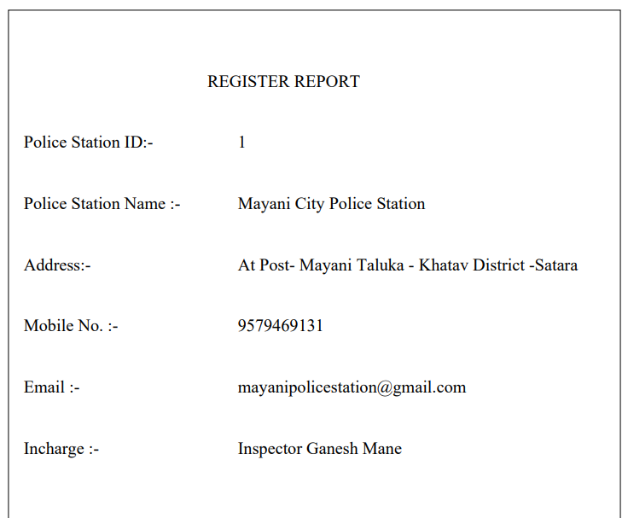

**2)Cognizable FIR PDF:**

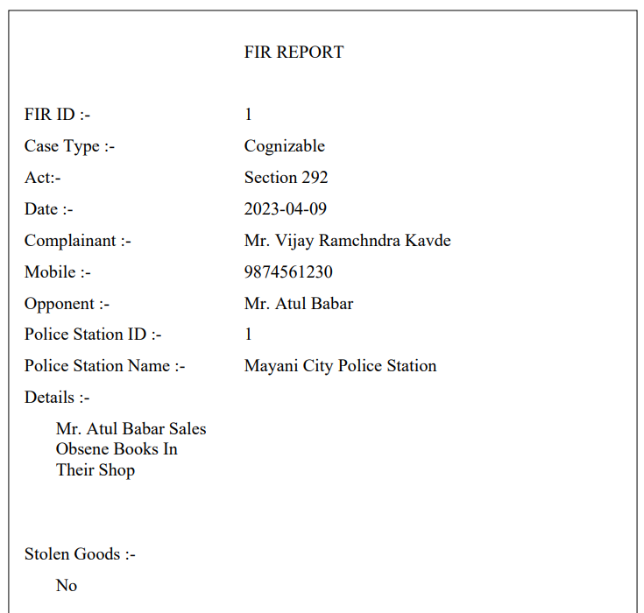

**3)Non Cognizable FIR PDF:**

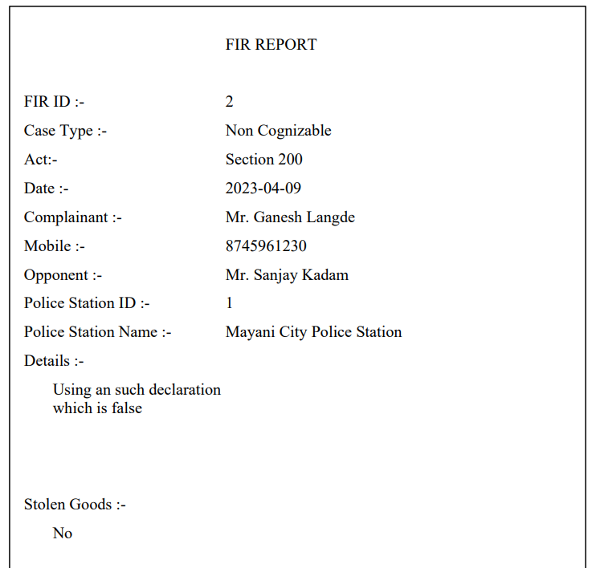

1. **)FIR Progress Details:**

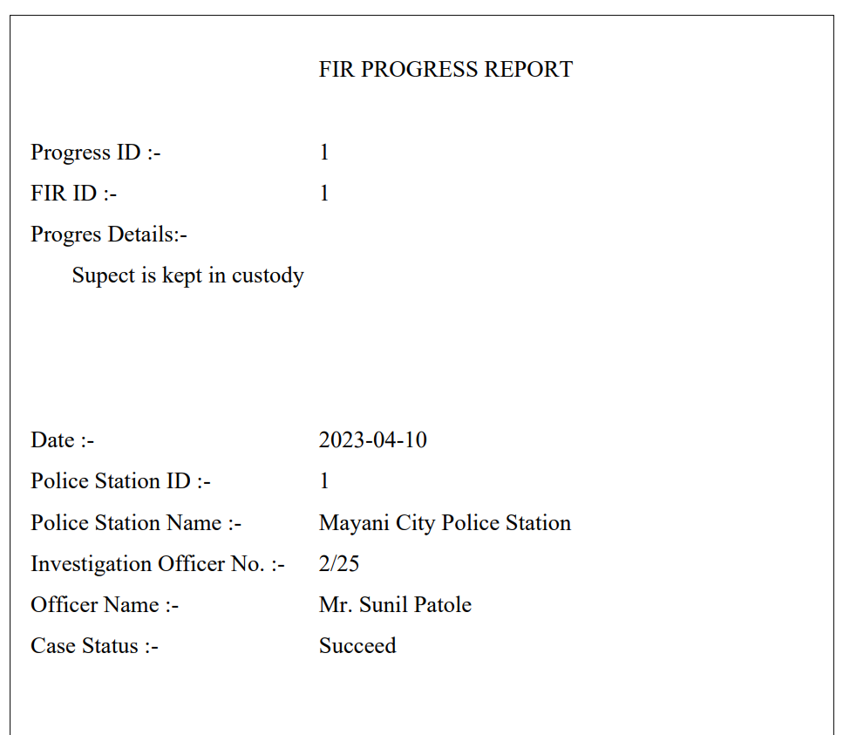

**5)Suspect Details PDF:**

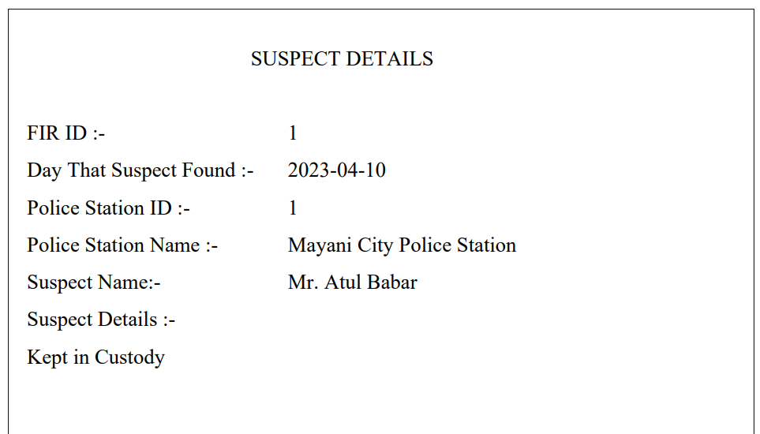

**5)Daily Diary PDF:**

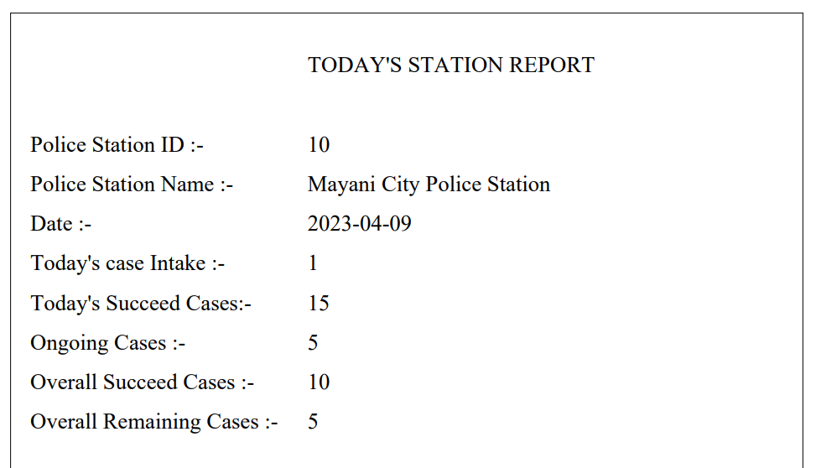

**Chapter – 7**

**Advantages and Limitation Of System**

* **Advantages of system :**
* Proposed system requires less man power.
* Speed of computer is high so it can perform operation fastly.
* Results are more accurate and automatic calculated.
* Storage capacity is high.
* Operation on data can be done quickly as per requirement.
* This system also use to current and quick.
* There is no loss data.
* Using computer addition, modification, view, deletion, of record is quickly possible.
* The main objective is to provide security, authority conclusion and further privacy and also is any unauthorized person cannot destroy or get information.
* Full support for object oriented programming.
* Structured error handling capabilities.
* **Limitation of System :**
* Only Computer Literate use these Project.
* It is web applications so we have to host on internet(internet charges apply for every year)

**Chapter – 8**

**Conclusion**

* **Conclusion :**

So, the outcome of all the hard work done for the Online FIR (First Information Report) system is here. It is software that helps the user to work with the Police Stations and crimes easily. This software reduces the amount of manual data entry and gives greater efficiency. The User Interface of it is very friendly and can be easily used by any police officer. It also decreases the amount of time taken to write FIR details and other modules.

All the details about any complaint and any other criminal can be checked and can be saved. In the end, we can say that this software is performing all the tasks accurately and is doing the work for which it is made.

**Chapter – 9**

**Future**

**Enhancement**

* **FutureEnhancement**
* The Online FIR(First Information Report) System could reduce the manual work and physical entities of the system.
* This Project can useful for any Investigating Agency.
* New acts can be added.
* It’s data can be handover to any other investigating Agency.
* Calculation Part Can be Added
* The system can be further enhanced by proposing an advance system.
* The system can be further enhanced by proposing an advance Facilities.
* In future due to increase in records of database file, data redundancy occurs.
* More modules can be included to keep track of occurrence.
* Generation of financial reports financial hierarchical detailed information about profit.
* System can be implemented as Desktop Application as well as Android App.
* We have not included various offers options in current system
* We have not maintained the process of mobile repairing

**Chapter – 10**

**Bibliography**

* **Bibliography:**
* **Reference:**

[www.google.com](http://www.google.com)

[www.youtube.com](http://www.youtube.com)

[www.advocatekhoj.com](http://www.advocatekhoj.com)

[www.mahapolice.gov,in](http://www.mahapolice.gov,in)

[www.w3schools.com](http://www.w3schools.com)

www.lovelycoding.org

[www.javatpoint.com](http://www.javatpoint.com)

[www.wikipedia.org](http://www.wikipedia.org)

* **Books:**

**Head First Java-**Kathy Sierra,Bert Bates

**Java The Complete Reference-**Herbert Schildt

**OCA Java SE 8-** Kathy Sierra,Bert Bates,Elisabeth Robson

**Thinking in Java-**Bruce Eckel